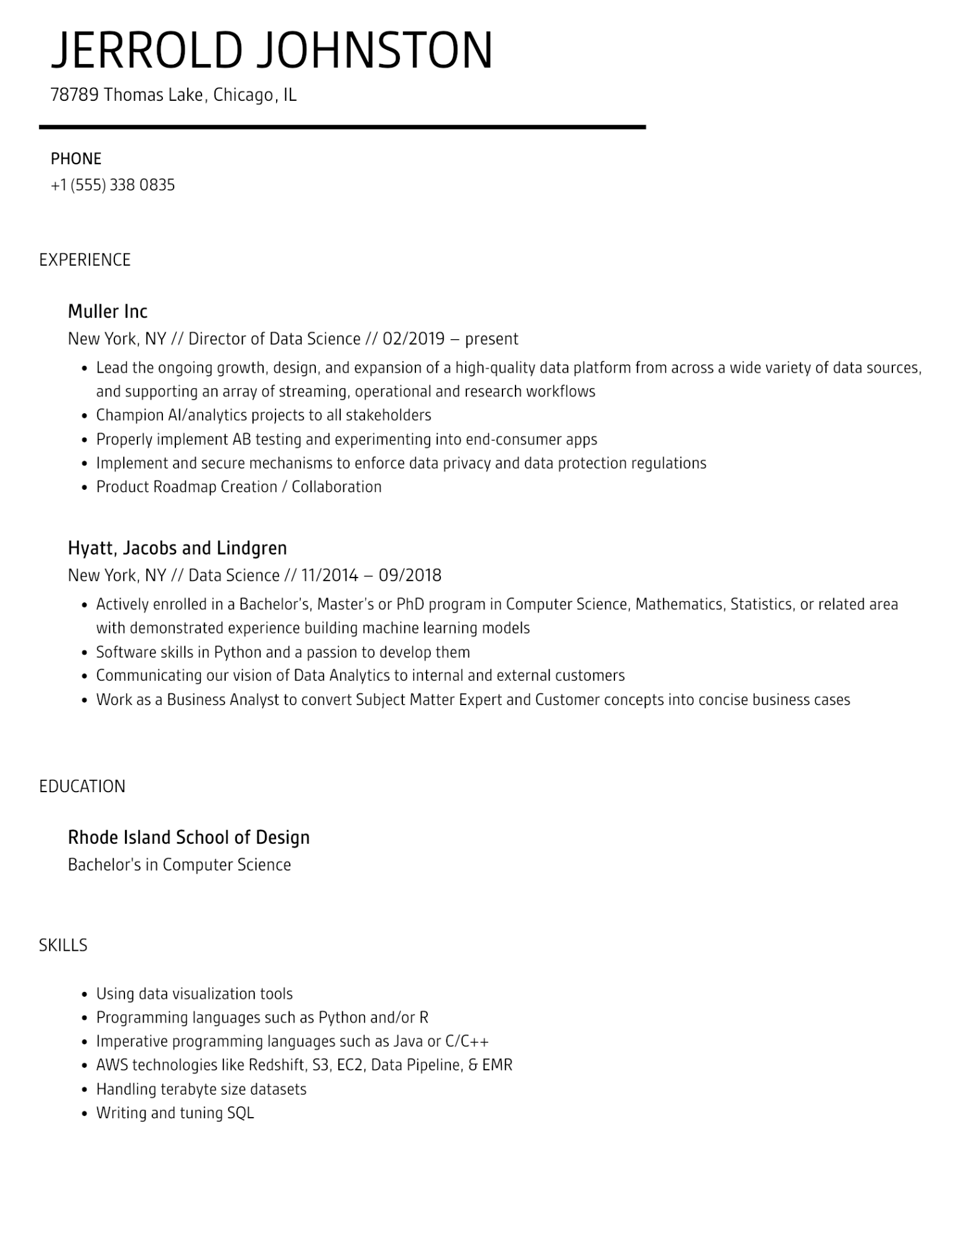
JERROLD JOHNSTON
78789 Thomas Lake, Chicago, IL
PHONE
+1 (555) 338 0835
EXPERIENCE
Muller Inc
New York, NY // Director of Data Science // 02/2019 - present
• Lead the ongoing growth, design, and expansion of a high-quality data platform from across a wide variety of data sources,
and supporting an array of streaming, operational and research workflows
•
Champion Al/analytics projects to all stakeholders
·
Properly implement AB testing and experimenting into end-consumer apps
·
Implement and secure mechanisms to enforce data privacy and data protection regulations
• Product Roadmap Creation / Collaboration
Hyatt, Jacobs and Lindgren
New York, NY // Data Science // 11/2014 - 09/2018
•
Actively enrolled in a Bachelor's, Master's or PhD program in Computer Science, Mathematics, Statistics, or related area with demonstrated experience building machine learning models
• Software skills in Python and a passion to develop them
·
Communicating our vision of Data Analytics to internal and external customers
• Work as a Business Analyst to convert Subject Matter Expert and Customer concepts into concise business cases
EDUCATION
Rhode Island School of Design
Bachelor's in Computer Science
SKILLS
•
Using data visualization tools
·
•
Programming languages such as Python and/or R
Imperative programming languages such as Java or C/C++
• AWS technologies like Redshift, S3, EC2, Data Pipeline, & EMR
·
Handling terabyte size datasets
•
Writing and tuning SQL

